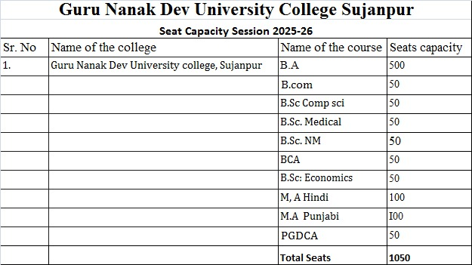

**UG COURSES**

|  |  |  |  |  |
| --- | --- | --- | --- | --- |
| **Sr. no.** | **Course name** | **Duration** | **Eligibility** | **Seats** |
|  | B.A. | 4 Years | 10+2 in any stream | 500 |
|  | B.Sc Medical | 4 Years | 10+2 with Biology | 50 |
|  | B.Sc Non-Medical | 4 Years | 10+2 with Physics & Math | 50 |
|  | B.Sc Computer Science | 4 Years | 10+2 with Math | 50 |
|  | B.Sc Economics | 4 Years | 10+2 in any stream | 50 |
|  | BCA | 4 Years | 10+2 in any stream | 50 |
|  | B.Com Hons. | 4 Years | 10+2 in any stream | 50 |

**PG COURSES**

|  |  |  |  |  |
| --- | --- | --- | --- | --- |
| **Sr. no.** | **Course name** | **Duration** | **Eligibility** | **Seats** |
|  | M.A. (Hindi) | 2 Years |  | 100 |
|  | M.A. (Punjabi) | 2 Years |  | 100 |
|  | PGDCA | Department of Computer Science and Applications | Bachelor's Degree in any stream | 50 |